**Overview**

We understand that the majority of our subscribers don’t follow all eight European leagues as closely as we do and that for many subscribers, Underdog Analytica could be their entry into the sports gambling scene. Whether you’re a seasoned veteran or first-timer, here is a quick course on football (soccer) betting using Underdog Analytica.

Football matches can end in one of three ways: home team wins, away team wins, or a draw (scores equal). After 90’ + added time (determined by time used on injuries or goal celebrations), the match is over and the end result is finalized. The European football season lasts roughly 40 weeks from September to June.

**Units**

This is where your risk tolerance as a gambler comes in. A unit is the base value you are willing to wager on your bets. We recommend you set your unit to a value you feel comfortable multiplying across 20-25 bets every week. For some people, this is €1 and for others, €20. It’s your money, so choose a value you can use for multiple weeks, too.

If you wager a common unit across all bets we suggest, which is the strategy we recommend, Return = (your unit value) x (total units won or lost**)

* **We take care of adding up this value, so all you need to do is multiply your unit value

**Odds**

When two teams play each other, there is a favorite and an underdog. The favorite is expected to win, so if you bet one unit on a favorite to win and they do, you will make less than one unit in profit. However, if you bet one unit on the underdog to win and they do, the result is a greater than one unit profit! That’s why we only recommend bets on the underdogs. Take a look at the example below for more details.

* Manchester City is playing Brighton. Manchester City is one of the best teams in the English Premier League, and Brighton is in the lower half of the rankings, so it is expected that Manchester City will win.
* Let’s say the odds of Manchester City winning are 1.2, Brighton winning are 3.4, and the match ending in a draw are 2.7. If the decimal odds (European odds) are greater than 2, then the bet is considered an underdog.
* In this hypothetical situation, betting one unit on the match to draw will earn you 2.7 - 1 = 1.7 units in profit.
  + In European odds, (ODDS - 1) = PROFIT in units

Converting European odds (EO) to American odds (AO) when decimal is greater than or equal to 2 (Underdogs)

* (EO - 1) x 100 = +AO

Winning a favorite bet results in a profit of less than one unit, and losing a favorite bet results in loss of more than one unit.

However, winning an underdog bet results in a greater than one unit profit, and losing an underdog bet results in only a one unit loss. This is the beauty of only betting on underdogs.

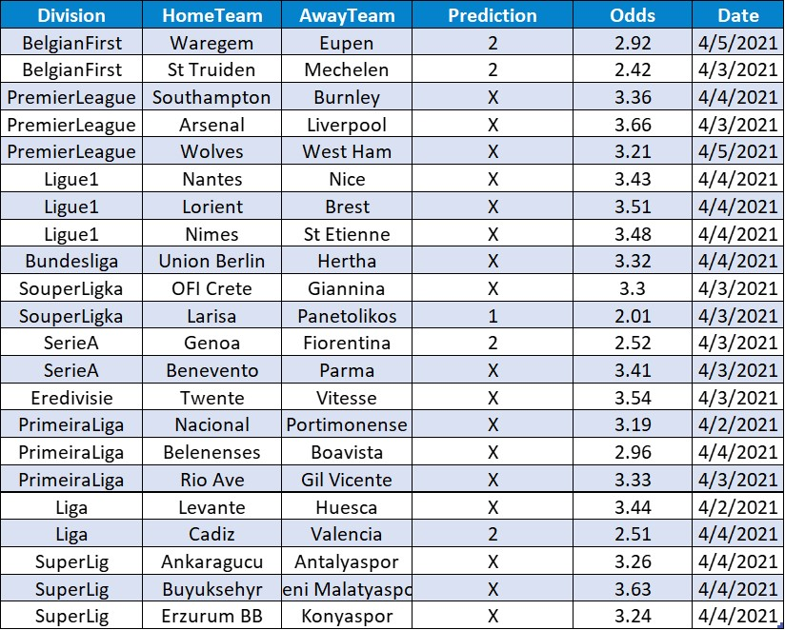

**Reading Picks & Making Bets**

Division:

Every team belongs to a division in a league in a country. This is where you will find the matches at your sportsbook.

Prediction:

1 = Home team wins

2 = Away team wins

X = Draw

Odds:

We take our odds from Pinnacle sportsbook in Europe. Be prepared for fluctuations in these values across sportsbooks, and don’t forget to use the conversion formula above to convert to American odds if you’re in the United States.

To make a bet, you will need to sign up with a legal sportsbook in your state/region/country. A simple search should return sportsbooks that are available to you locally, but we recommend reading reviews before committing. We are in the process of conducting research for our subscribers on verified sports books around the world.

Have questions? Let us know at [info@UnderdogAnalytica.com](mailto:info@UnderdogAnalytica.com)